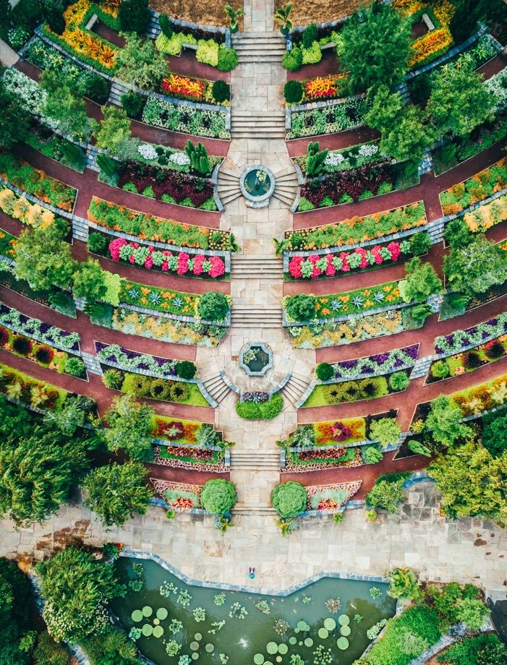

***Mesa en Espa*ñ*ol***

Come and practice your Spanish conversation skills All levels welcome!!!

Monday@Languages 114 5:30-6:30pm

Dates

Jan. 14, Mar. 18, 25

Feb. 11, 18, 25 April, 8, 15

Special Event: Cooking Class February 4th, 5:00-7:00pm @ Smith Ware House Bay 6, Room 265

Come and learn how to cook delicious Latin plates!!